GREAT CUMBRAE WIND FARM FEASIBILITY STUDY

Final Report

**Group 10**

|  |  |  |
| --- | --- | --- |
| **Matriculation Number** | **Team Members** | **Member Roles** |
| 2383616 | Sham, Allan On Ching | Design Manager |
| 2318425 | Bu, Sicong | Construction Manager |
| 2285081 | Ding, Hao | Information and Research Manager |
| 2309728 | Dong, Jinxi | Engineering Manager |
| 2345137 | Li, Shenao | Health and Safety Manager |
| 2295429 | Zhang, Yiwei | Quality Manager |
| 2292242 | Chen, Dian | Project Accountant |
| 2346557 | Alvarez Geronimo, Daniel | Environmental Manager |
| 2247014 | Yin, Yaohua | Engineering Manager/Project Planner |
| 2352250 | Dowds, Matthew | Project Manager/Project Planner |



SUMMARY

The purpose of this project was to determine whether it was feasible to install wind turbines on the island of Great Cumbrae. To achieve this the group researched information such as council regulations, site selection, wind turbine design, construction, finance and environmental impacts. Once a site was selected the process of identifying the feasibility of the project commenced. It was clear that there are a number of concerns relating to the implementation of wind turbines in Great Cumbrae, as the region of Great Cumbrae has a very sensitive landscape. This limited the number and size of the turbines that were appropriate for Great Cumbrae. It was found that there were no technical reasons why the project could not be implemented. Additionally, the project has no major environmentally and makes some high CO2 savings. Although, there are some concerns with the financial feasibility of the project. Overall, this study recommends that the windfarm design project is technically and environmentally feasible. Our organisation would also advice performing feasibility studies with other renewable technologies to identify whether Great Cumbrae can become fully sustainable.

Due to the restrictions mentioned in the previous paragraph the selection of wind turbine was greatly limited. In the end, 5 WES100 turbines rated at 100kW was chosen to achieve our goal of powering as many households as possible. It was calculated that these 5 turbines will generate around 860MWh a year with a lifetime of 20 years the total estimated output is hence 17.2GWh.

In terms of safety, a risk assessment was conducted and all stages of the wind turbine project. The main risks were found to occur during the construction phases. For example, when lifting the big tower sections with the crane, working with machinery, or working at heights etc. Precautions to mitigate these hazard as well as possible were thought out, but the team found there were still hazards that can be considered slightly high. To further mitigate risks, the team proposes a safety-first attitude whatever they may be doing on the worksite.

An environmental study was also performed. The emissions due to manufacturing, transportation and installation were calculated and compared to more tradition type of energy production. It was calculated that 1854tonnes of CO2 can be saved with the proposed project. With a payback period of 5.4% of the life expectancy of the turbines. Other factors such as noise, shadow flicker, signal interference and environmental integrity were researched, these aspects were found to cause minimum disruption to the surrounding area and public.

The capital investment of the project was calculated to be £1,109,440. The annual income from selling electricity to the grid was estimated to be £111,972. Hence, the company will begin to profit at the 15 year mark. The ROI of this project is 0.24 and the project breaks even when the loan interest rate is 3.32%. The profitability index of the project is 0.65, which means that this project may have insufficient profitability. However, it may be possible to receive government funding.

It is estimated that the project will take no longer than 8 months from site surveying until the wind farm becoming operational. The majority of this time will be getting the site ready, for example building the access roads and concrete foundations for the 5 turbines. Once the foundation are set the turbines can be constructed, this will take no longer than 2 months. Lastly the turbines will be tested and commissioned ready for operation.

Contents

SUMMARY 1

1. Introduction 4

1.1 Project Overview 4

1.2 Island Background Information 4

2. Wind Turbine Site Selection 4

2.1 Ayrshire Council Regulations 4

2.2 Great Cumbrae Site Parameters 5

2.3 Planning Application 6

3. Wind Turbine Specifications 6

3.1 Wind Turbine Selection and Change of Project Scope 6

3.2 WES 100 7

3.3 Grid Connection 7

3.4 Wind and Power Calculations 8

3.4.1 Wind Speed Distribution 8

3.4.2 Power Curve and Total Energy Output 9

3.5 Micro-siting 10

4. Wind Turbine Site Operation 10

4.1 Component Information 10

4.2 Transportation 11

4.3 Installation 11

4.4 Maintenance 12

5. Identification of Site Standards 12

5.1 Risk Assessment [28] 12

5.2 Environmental Risks of Great Cumbrae 13

5.3 Quality Report 14

6. Environmental Impact Report 14

6.1 Carbon Emissions and Payback Calculations 15

6.2 Other Environmental Impacts 18

7. Financial Analysis 19

7.1 Total Cost Calculation 19

7.1.1 Capital investment 19

7.1.2 Operational Cost 20

7.2 Total Income Calculation 20

7.3 Cash Flow and Feasibility Analysis 21

7.4 Financial Summary 22

8. Project Development and Work Schedule 22

8.1 Windfarm Development 22

8.3 Work Schedule 23

9. Conclusion 24

10. References 26

Appendix A: Site Diagrams 31

Appendix B: WES100 Specification [11] 32

Appendix C: Wind Data Collected from Meteoblue [18] 35

Appendix D: Power Curve and Energy Production of the WES100 [11] 36

Appendix E: WES100 Diagram 37

Appendix F: Natural Frequency and Vortex Shedding 38

Appendix G: Risk Assessment [55] [28] 40

Appendix H: Financial Breakdown 42

1. Introduction

1.1 Project Overview

The objective of this study is to produce a feasibility report to identify whether wind turbines can be placed on the island of Great Cumbrae. This report will consider the technical and non-technical aspects of the study and places importance on the financial considerations of the project. The project required aspects of all major disciplines of engineering, combined with broader considerations of project management, environmental issues, accountancy, health and safety and quality management. Using effective teamwork and communication, information from each project department was distributed to each team member to complement their work. The report identifies details of Great Cumbrae relevant to the case study, along with the Ayrshire Council Regulations this information allowed for the selection and modelling of a planning application for that site. The wind turbine specifications will be in line with regulations to produce the maximum amount of power for Great Cumbrae. Additionally, an environmental impact assessment will be completed to access the implications of the proposed wind farm. The financial analysis of the wind farm will include income and cost calculations then a discounted cash flow that will consider the whole project life cycle. The project development will consider sustainability and end-of-life issues to determine the feasibility of the site.

1.2 Island Background Information

Our team’s company is considering constructing wind turbines on the island of Great Cumbrae. Great Cumbrae is approximately 11.68 km², therefore this area will be analysed for potential sites. Great Cumbrae had a population of 1362 in 2013, with around 90% of the population living in the town of Millport [1]. In Millport there are 711 houses (2011) of those houses 49.5% are one-person houses, 35.4% are 2 people households, which means overall the average number of persons per household is 1.8 [1]. The island’s community is controlled by Scottish and Southern Electricity Network and is supplied by submarine electricity cables [2].The project’s aim initially was to generate sufficient electricity to meet the island's needs, although after assessing the region it was clear that a smaller scale wind turbine project was the only option.

1. Wind Turbine Site Selection

2.1 Ayrshire Council Regulations

The Scottish Government has set a target to generate the equivalent of 100 per cent of Scotland's gross annual electricity consumption by 2020. It is therefore the duty of Planning Authorities to have up to date policies which can guide wind farm development, so that continued investment is possible. The region of North Ayrshire has significant wind energy resources which makes it an attractive location for developers [3].

When selecting an appropriate site for wind turbines in Great Cumbrae several factors had to be considered, such as:

* Visual Impacts
* Historic Environment
* Natural Heritage Sites
* Tourism and Recreational interests
* Communities
* Buffer Zones
* Aviation and Defence Interests
* Broadcasting Installations
* Agriculture
* Landscape Sensitivity
* Landscape Value
* Cumulative Impact

The scale of these impacts will help determine whether the Ayrshire Council grants permission to build wind turbines on selected sites. The council report also provides diagrams of Great Cumbrae and displays relevant information for site selection, as shown in *Table 1*.

*Table 1: Great Cumbrae Impact Assessments*

|  |  |  |  |
| --- | --- | --- | --- |
| **Areas of Significant Protection** |  | **Technical and Other Constraints** |  |
| **Areas of Potential Constraint** |  | **Wind Resource (above 6.5 m/s)** |  |
| **Aviation and Defence Interests – Radar Sensitivity** |  | **Landscape Highly Sensitive to Small Scale Windfarms** |  |

In Ayrshire the landscape is also seen as a major asset in economic development, tourism, leisure and recreation as well as a source of pride and pleasure to residents. Public awareness of changes in landscape brought about by development proposals is increasing, particularly in relation to wind farm developments. The commitment to sustainable development now enshrined in planning legislation requires that the character and qualities of the landscape are maintained in all their richness and diversity.

These regulations showed that wind turbines would have significant impacts on the character of the Great Cumbrae landscape. Therefore, to limit environmental impacts, 5 wind turbines with a typology of less than 30metres were selected for use [4]. These wind turbines could only be built on the coastal fringe with agriculture. Additionally, the site with the highest wind speed was on the south west side of Great Cumbrae. After all these considerations, the best site available was decided to be located nearby Gowk Stone, as it was within regulation and situated out with any Scottish Wildlife Trust Sites [4]

2.2 Great Cumbrae Site Parameters

Great Cumbrae’s character type has many different aspects. There is a sense of a small-scale landscape on the island due to the rugged hilly core of the island and the presence of small features including farms and other buildings and trees. The western side comprises of a raised beach coast which forms a prominent low cliff and is covered in broadleaved woodlands. The town of Millport is situated on the south facing bay and has a strong architectural integrity [5]. Great Cumbrae is popular with cyclists and walkers and also provides a key focus seen from parts of the North Ayrshire Coast, increasing visual sensitivity.

The wind turbines could only be built on the ‘coastal fringe with agriculture’ shown in green in Appendix A1 [6]. As the Purple region which is called the ‘rugged island core’ was deemed to have no capacity for wind turbines due to the landscape sensitivity, according to the Ayrshire Council. Furthermore, the turbines could not be sited close to the coast or nearby the top of cliffs, as they are prominent features seen from the coast road. After all these considerations, the best site available was nearby Gowk Stone, as it is within regulation and situated out with any Scottish Wildlife Trust Sites, shown in Appendix A2 [7].

2.3 Planning Application

There is a Local Development Plan (LDP) that relates to land use. In this document it indicates where certain types of development are allowed to be built or not. The LDP regulations will be in place up to 2025 and it provides the policy framework for determining planning applications. The key stages of planning applications are as follows [8]:

1. There is an initial pre-screening assessment. Which identifies whether a plan will likely have significant environmental effects.
2. Scoping information about the plan and its potential environmental effects presented in the 'Environmental Report' requires consultation with the statutory consultees.
3. Environmental Report outlines the findings and is published and publicly consulted upon at the same time as the plan.
4. There is then a post-adoption statement which is produced after the plan has been adopted. It set outs how the Environmental Report and consultation comments have been taken into account within the finalised plan.
5. Finally, there is the monitoring stage which identifies the unforeseen, adverse environmental impacts of the plan. It then reports on this and advices on how to mitigate the impacts.

For more specific components of the wind turbine installation specialists will have to be approached. For example, the Directorate of Airspace Policy of the Civil Aviation Authority is the contact point for all wind turbine consultations. They then consult their own contacts to access the planning application. This is because wind generator turbines are a considered a threat to air navigation and can also impact signals radiated from and received by aeronautical systems. Furthermore, the blades may cause an electromagnetic disturbance which can cause problems in the performance of aviation systems [9].

1. Wind Turbine Specifications

3.1 Wind Turbine Selection and Change of Project Scope

One of the main criteria of the project is to supply enough electricity for the whole island of Great Cumbrae. Exact energy demand for Cumbrae was not found during research and hence an estimation was made based on a similar island, the Isle of Mull [10], leading to an estimation of 6GWh of energy consumed per year for Cumbrae. Research showed that many models of turbines can achieve this goal but as mentioned in the previous section, height restrictions of 30m per turbine and a maximum of 5 turbines in any one location placed by North Ayrshire council greatly limited the range of wind turbines suitable.

Further research found that wind turbines of under 30m maximum height are rated up to 100kW but often less. Quick estimation of the energy produced by a wind turbine can be calculated:

Where the capacity factor is the ratio between the actual energy output per year compared to the maximum theoretical energy output if the wind was blowing constantly at the rated wind speed throughout that year. The capacity factor is obviously affected by how often the wind blows but is typically around 20% - 30% for the UK. For a 100kW wind turbine, the estimated output is 219MWh a year (using a capacity factor of 25%) meaning at least 28 turbines rated at 100kW each are needed to power the whole of Cumbrae. Due to this reason, and the restrictions of Ayrshire council it was decided unfeasible to power the whole of Cumbrae while keeping within the regulations. It was hence decided to change the scope of the project from powering the whole island to powering as many households as possible with 5 turbines.

3.2 WES 100

After much research, the WES 100 by Wind Energy Solution (WES) [11] was selected as the main candidate to achieve this new scope. According to the WES website [11], “The WES100 is a two bladed, high performance, reliable 100 kW midsize wind turbine with a rotor diameter of 18 meters. This wind turbine is especially designed for areas with a higher wind speed.”

The main reason in choosing this turbine was due to the high power to height ratio. Many other brands of wind turbine rated at 100kW had a hub height of at least 28m, before counting the length of the blade. Furthermore, the WES 100 meets Ayrshire regulations of turbine size. The tower height comes in 3 sizes the smallest being 18m, the diameter of the blade is 17.9 hence, 18+(17.9/2) = 26.95m, below the 30m restriction. Appendix B [11], details some specification of the WES 100 collected from their website and from contacting WES directly via email.

3.3 Grid Connection

To distribute the electricity generated by the turbine to the general public, the turbines will have to be connected to the grid. This brings along several challenges including finding the nearest connection point (which will then transfer the electricity to the closest substation and into the grid), and a proposal made to the Distributed Network Operator (DNO) to connect the wind farm to the grid. The DNO owns, operates and maintains the electricity distribution network in the UK and permission will have to be received by them before connecting to the grid. For the case of Great Cumbrae the DNO is Scottish & Southern Electricity Networks [12].

Unfortunately, an official list of connection points could not be found on the internet hence some assumptions had to be made. Google street view shows small electric pylons heading towards Cumbrae golf course reception from the south, this will be assumed to be the connection point. The second assumption to be made is that the voltage carried by these small pylons is rated at the common 11kV [13]. As the grid voltage of the WES100 is 400V (Appendix B) a transformer will have to be installed inside the ground control unit of the turbines to transform this up to the required 11kV. Pylons and cables will then have to be erected south towards the connection point to transfer the electricity over. To further strengthen these assumptions and the choice of wind turbines, [13] mentions that “connection to higher voltages (ie. over 11kV) part of the network will likely be too expensive for” 50 – 500kW wind turbines.

Before connecting our turbines to the connection point, a network study must be done by the DNO, this include study on the connection method, metering arrangements, system protection requirements, etc to deem the system safe. Many codes will have to be adhered to including the: Distribution Code [14], Grid Code [15], the G59 Code [16]. These lengthy documents will not be covered in detailed in this report as this is mainly part of the work of the DNO.

One safety requirement that must be adhered to is that a G59 approved loss of mains relay must be installed. This piece of equipment continually monitors the quality and stability of the grid and when it detects something out of the ordinarily (eg. voltage or frequency) it activates the circuit breaker and disconnects the wind farm from the grid [17].

Because of the vast amount of the work that must be undertaken by the DNO this part of the project can be one of the more expensive part of the project. Email contacts through WES estimated this to cost £10,000 while [12] says it can cost over £500,000 for 500kW installations. For the purpose of this report a value of £10,000 will be used.

3.4 Wind and Power Calculations

3.4.1 Wind Speed Distribution

What follows is a more accurate calculation of the energy output based on wind speed data. The annual wind speed distribution data was downloaded from the MeteoBlue website [18]. Appendix C, collected from MeteoBlue [18], has a variety of simulated wind data for Cumbrae. It is important to note that this is simulated data based on a MeteoBlue’s climate model using previous collected data in the surrounding area. The actual detailed measured data costs money the team was not willing to spend. Since further calculation into the power generated are based on this data, variance between the following calculations and actual data might arise due to this.

The MeteoBlue [18] website also shows the exact number of hours blown for each range of wind speed over a year. This data was collected and plotted (Appendix C), the wind speed had to be fitted from 4 mph ranges into 1m/s increment. This involved some guess work and is another area where variation can arise. But again, with money, the full detailed data can be downloaded from MeteoBlue if needed.

The reason to split up the data into 1m/s increments is because most turbine manufacturers provide their power curve in 1m/s increments and this will allow for a more accurate estimate of the power generated per year.

The variation of wind speed due to difference in height was also considered using:

where:

= velocity of the wind (m/s) at height h

= velocity of the wind (m/s) at height 10m

α = Hellmann exponent

Again, some assumptions had to be made, this included that the MeteoBlue data was measured at a height of 10m and the Hellman exponent is 0.15 for Grassland [19]. Unfortunately, because of the restrictions on height by Ayrshire council, the hub height of the turbine is only 18m and therefore the wind speed and hence energy output only increases slightly at the hub height.

3.4.2 Power Curve and Total Energy Output

*Figure 1: Estimated Energy Production per Year.*

To accurately estimate the energy output of the WES100, the power curve must be obtained from WES’ website (Appendix D). The power curve shows the energy produced for a given wind speed. The wind energy is proportional to the velocity cubed hence the energy increases greatly as wind speed increases but as the WES 100 is only rated to 100kW the curve levels out, this happens at around 15m/s.

Multiplying the wind speed distribution by the power curve the energy output at each wind speed can be calculated (Figure1). Summing up the magnitude of each bar gives the estimated energy produced per year at 172MWh. As the restriction of Ayrshire councils only allows 5 turbines, the total energy output per year of 5 WES100 is (5*172=) 860MWh per year.

Interestingly, the energy output at 15m/s is a lot higher than the energy produced at 14 or 16m/s. This is due to the points raised previously: energy increases greatly as wind speed increases; the turbine is limited to 100kW which begins when the wind reaches 16m/s and because the number of hours at 15m/s in a year is slightly greater than 14m/s (Appendix C). Although, this last point could be due to fitting of the MeteoBlue data into 1m/s blocks.

With the total energy produced in one year known, the capacity factor can be estimated:

This is a typical value for the UK, although maybe slightly low for the west coast of the UK, this can be down to the data from MeteoBlue. Comparing the energy output calculated above (172MWh) and the number WES estimated based on mean wind speed (Appendix D), mean speed of Cumbrae is ~6.5m/s (Appendix C) giving 204.5MWh a year. WES seem to have used a capacity factor of ~23% giving them a slightly higher estimate in output energy per year. Obviously, the wind speed is not something that can be predicted 100% accurately and hence neither can the energy. From now on, 172MWh will be used as the single turbine energy output in a year, to not overestimate.

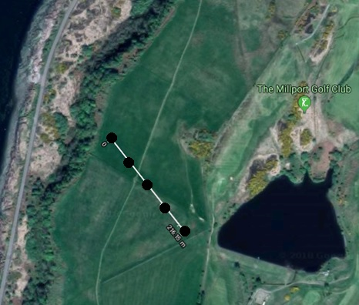Finally, knowing the lifetime of the wind turbine to be 20 years (Appendix B) the total energy produced by the 5 wind turbines its expected lifetime is 17.2GWh.

3.5 Micro-siting

The arrangement of the 5 turbines on the site is important to maximise power output. If turbines are lined up in a column one behind the other against the prevailing wind, the wake of the front most turbines cause significant reduction in wind speed and an increase in turbulence behind it. This not only reduces the electricity produced but also decreases the life span of the turbines [20].

Therefore, it is proposed to line up the 5 WES100 perpendicular to strongest winds, this being the west-southwest direction for Cumbrae (**Error! Reference source not found.**Appendix C). A common rule of thumb specifies three to five rotor diameters between turbines [21]. Due to the lack of space at Gowk Stone from the road to the west and golf course to the east, a spacing of 3 times the rotor diameter is proposed (From Appendix B, 17.9m*3=54m). Figure 2 the proposed location of the 5 WES100 turbines along the white line, facing the WSW direction. The distance between the first turbine to the last turbine in the line will be approximately (54*4=) 216m.

Figure : Micro-siting of the 5 Turbines (Image from Google Maps)

1. Wind Turbine Site Operation

4.1 Component Information

After contacting WES, the provided details relating to the shipment and wind turbine dimensions were obtained. For the 18m tower wind turbine, the delivery of component information is as *Table 2*.

*Table 2: Component Information of 18m Tower*

|  |  |  |
| --- | --- | --- |
| **Shipment** | **Weight (kg)** | **Length (m)** |
| Blade 1 | 100 | 7.8 |
| Blade 2 | 100 | 7.8 |
| Nacelle | 2,200 | N/A |
| Generator | 400 | N/A |
| Gearbox (incl. oil) | 820 | N/A |
| Control cabinet | 400 | N/A |
| Tower section 1 (base) | 2085 | 6.0 |
| Tower section 2 (top) | 3128 | 12.0 |

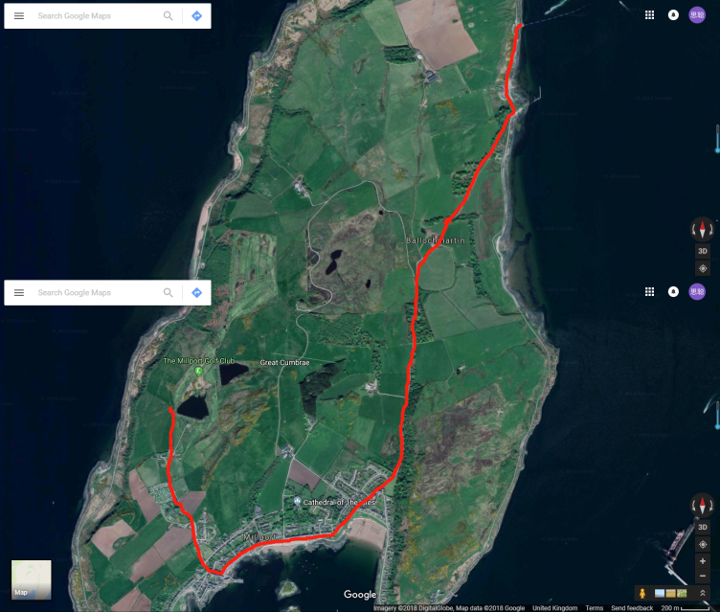It was confirmed by WES that each wind turbine would fit into one standard curtain sided trailer (dimensions of 13.42m x 2.49m x 3.00m), so the weight and length of all the components are acceptable. The construction equipment for this project are listed below [22]:

* Hydraulic truck crane
* Rough terrain forklifts
* 2 pick-up trucks

4.2 Transportation

The delivery schedule and the method of delivery are very important in the construction of a wind turbine project [23]. Furthermore, to minimize disruption we aim to work between the hours of 8am to 6pm, Monday to Friday [24].

After considering transport surveys, load permits, social and environmental impacts, the two main delivery routes were determined. To begin with, all the components will be shipped to Cumbrae Ferry Terminal and then delivered to the construction site. The distances by sea and by road are approximately 1.87km and 6.43km, respectively.

Figure : Transportation route by road (Image from Google Maps)

Figure 3 shows the route for transportation to the construction site, turbines can travel in sections to minimize each load’s weight [25]. All the components and heavy construction equipment would be stored and assembled on site. Considering the size of our wind turbine it is estimated that we just need three trucks for transportation.

4.3 Installation

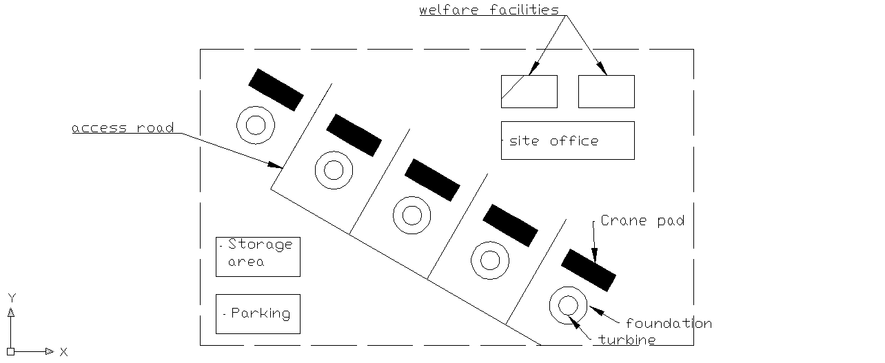

*Figure 4: Provisional Site Plan layout using CAD*

The layout for construction area shown in Figure 4 is approximately 35,000m2.

The first step of the site delivery will be to perform a construction site survey to ensure the wind turbines’ location, construction area, where the access road, crane pads and the location of pylons should be.

The next stage is to clear the site and construct an access road for delivery of turbine components and construction equipment. We plan on constructing 4 access roads to each of the 5-wind turbine, these 4 roads will link to the main access road which connects to the existing main road. This is essential for component delivery, operation and maintenance after construction is completed. The width of the main access road will be approximately 40 feet. After construction is completed, the access road would be altered to approximately 15 feet permanent road.

It is also vital to design a drainage system to prevent water flow along the road surface. Additionally, the road’s vertical grade should be limited to no more than 8% [26].

There are four main steps for constructing the foundation. Firstly, engineers would need to remove and stockpile topsoil and subsoils. And these two kinds of soils should be reserved separately. The second step is to excavate holes, place reinforcing steels and pour concrete. Next, is to backfill the foundation. Finally, the foundations need to be left for approximately 1 month to cure before the tower installation can begin.

After the foundation is constructed and backfilled, the crane pads can be built which allows for turbine erection. These crane pads would remain for operation and when maintenance is required.

The lower section of the tower needs to be set on the turbine foundation which will take approximately seven hours, and the upper tower section will be placed on top of the lower section. Afterwards, the nacelle, hub, and the two blades for each turbine will be installed step by step.

The 5 turbines will be connected to a central control room next to the southernmost turbine (Figure 2). The generated power from the wind farm will be transported via cabling and directed to the nearest connection point which is located at the golf course. Therefore, we will need to place pylons for holding the cables from the site to the connection point, which is approximately 220m.

When construction has been completed, the site will need to be cleaned up and the area around the turbines should be restored to its original condition.

4.4 Maintenance

As it is important to maximise the annual energy output of the wind farm, WES recommends maintenance to be carried out twice per year. The various levels of maintenance are as follows [27]:

1. Remote reset offsite.
2. Internal inspections and minor repairs need personnel and tools, repair time 2 to 6h.
3. External inspections and minor repairs need personnel and tools, repair time 6 to 10h.
4. Replacement of small parts requires a crane and forklifts. The maintenance time is usually 8 to 24h.
5. Identification of Site Standards

5.1 Risk Assessment [28]

Risks of workers related to wind turbine can happen during any major phases of the life cycle of wind turbine: transportation, installation, operation, maintenance, and decommissioning. There are also risks related to the environment of Great Cumbrae.

*Table 3* shows the risk factor table employed in the risk assessment, the severity and probability of risks, the severity is multiplied by the probability to calculate the risk factor, a higher risk factor indicates a higher risk to the health and safety of the workers or the public. If the risk factor falls below 5, after the necessary precautions have been taken, then the hazard is successfully mitigated.

|  |  |  |  |  |  |
| --- | --- | --- | --- | --- | --- |
| **Severity →** | Minor Injury | Lost time ≤7 days | Lost time >7 days | Permanent  Disability | Fatality |
| **Probability ↓** |
| Highly Unlikely | **1** | **2** | **3** | **4** | **5** |
| Unlikely | **2** | **4** | **6** | **8** | **10** |
| Possible | **3** | **6** | **9** | **12** | **15** |
| Probable | **4** | **8** | **12** | **16** | **20** |
| Certain | **5** | **10** | **15** | **20** | **25** |

*Table 3: Risk Factor*

Appendix G outlines the hazard, the associated risk factor, ways to control the hazard and the risk factor after the controls have been implemented. The main risks occur during the construction phase. During this phase, all workers at the site are expected to wear personal protective equipment (PPE). The minimum being safety helmet, gloves and steel toe cap boots. Although if certain work dictates, additional equipment must be worn, for example if a worker must work at height when installing the nacelle to the tower, a harness must be worn as well as the minimum PPE.

One of the main hazard occurs when lifting the heavy equipment for example erecting the two tower sections and lifting the nacelle up to the erected tower. During these challenging operations everyone will have to maintain good communications. Normally, there will be one banksman in direct contact with the crane operator to avoid conflicting messages given to the operator. The use of hands-free tool is recommended to push or pull the equipment being lifted to minimise hand injuries and to keep the body in a safe a position as far away from the equipment as possible. Furthermore, at least one tag line should be attached to the equipment to minimise the swaying of the equipment once out of reach of the hands-free tool.

After efforts to reduce the operational hazards the majority of concerns have met safety requirements. The two hazard which still have a risk factor above 5 are of the less severe but high probability category. These being the hazards relating to slips, trips and the hazards under the “operational disease” category for example working in uncomfortable position or work with repetitive body movements. This is a type of paradox, humans are generally more alert on safety when doing high profile tasks such as lifting an enormous object (i.e. tower sections) and hence less accidents occur but when it comes to more mundane everyday task (such as lifting or hammering) the mind is less focussed, and hence more injuries or accidents occur.

5.2 Environmental Risks of Great Cumbrae

The wind farm is established at Gowk Stone in Great Cumbrae, the risks to workers are related to landform, climate and environment of the island.

* Due to the maritime climate, Great Cumbrae can experience strong winds from the Atlantic at any time of year; these gales form west or south-west can be severe and destructive. Gowk Stone is located at south-western side of Great Cumbrae.
* Gowk Stone is located at the back side of a hill, there is only one town called Millport on the island. The transportation of wind turbine parts to the site will have to travel along some narrow roads causing some risks to the public.
* The road on Great Cumbrae up to Gowk Stone is too narrow, so an access road will need to be built before the transportation of wind turbines parts can begin. The process of building the access road is also a risk to the safety of workers.

The risk factors of all risks (Appendix G) can be controlled below 5 except for the two mentioned above: slips, trips and the “operational diseases”. To further control these type of risks, all workers should be reminded to focus on safety during all phases of work even when doing simple everyday tasks. Furthermore, a safety-first mentality should be conveyed, where every personnel not only have the right, but the obligation to stop any work deemed unsafe. If this can be achieved, the risks caused by this wind turbine project can be controlled.

5.3 Quality Report

The Quality Assurance Plan is very important to ensure that all steps of the project are monitored, all components of the system are tested and the check-out process is determined. The process provides quality assurance by testing, correcting, retesting and reviewing sessions [29].

The Quality Plan specifies the responsibilities and procedures to ensure that the data and information produced as a part of the wind turbine project are reliable, achieve the purpose, objectives and deliverables. It shows internal management and ensures project quality.

The following methods can be used to ensure that the wind turbine project meets the high standards of quality requirements:

**Calibration and Testing**

All devices need to be tested and calibrated before integration, such as turbines, transformers, and wiring. After integration, it is tested and calibrated again [30].

**Internal Audit**

Internal auditing is a catalyst for improving an organization's governance, risk management and management controls by providing insight and recommendations based on analyses and assessments of data and business processes [31].

**Corrective and Preventive Action**

Corrective and preventive actions are improvements to the procedures that the project uses to eliminate nonconformities or other undesirable conditions. In terms of manufacturing, documentation, procedures or systems, the team is required to continuously correct and eliminate recurrent bad behaviour.

**Quality Assurance Sessions**

Quality assurance sessions need to be held on a regular basis and must be held strictly in accordance with the project progress cycle. The meeting is to determine the quality of the current project progress, and according to the results of the meeting to make changes to the original plan.

**Identification, Labelling and Control**

For unqualified products, they need to be identified and controlled to prevent their unintentional use, delivery or processing.

**Documents and Records**

The project team should have a corresponding record of changes to the project plan. There should be a corresponding backup of files and records. If there are documents of functional technical requirements, signatures from users and technicians are required.

1. Environmental Impact Report

Following the lines of the feasibility study the environmental impact plays a key role in the decision making of the present project. The absence of it can lead to the negation of planning or construction permissions by the Scottish organizations. Renewable Obligation (Scotland) states that Scotland aims to produce the equivalent of 100% of the annual electricity consumption by 2020. They take into consideration the studies by organization such as Scottish Renewables (SR), Scottish Natural Heritage (SNH), Scottish Environmental Protection Agency (SEPA), Forestry Commission Scotland (FCS), Historic Environment Scotland (HES). Therefore, our feasibility report concerning environmental safety follows the approach stated by these organizations and more specifically the Ayrshire Council guidance for wind farms where the island of Great Cumbrae is located.

The Ayrshire Joint Structures Plan approved in 2007 is a guide on turbines and wind farms locations to provide greater clarity to developers. More specifically, the North Ayrshire area has emitted capacity studies together with SNH where the preferences for smaller wind farms and turbines are recommended [5] to minimize the effect to the landscape.

This section is divided into two subsections. The first is related to calculations concerning the carbon emissions of the proposed project of 5 WES100 wind turbines in Gowk Stone on Great Cumbrae. These calculations are made through the life cycle of the turbines. The second section covers the impact that this project can bring to the people of the island and other environmental considerations based on the studies and regulations made by the previous organizations mentioned above.

6.1 Carbon Emissions and Payback Calculations

It is a clear statement that renewable wind power is not carbon free. But, even as a low carbon power the calculation varies according to what is considered as the variables of the studied during the life cycle of the turbines. For this reason, some estimations of values must be made for the calculations. The carbon savings cannot be estimated as equal to the equivalent emissions for coal or other conventional generation that it displaces for the simple reason there are a non-zero emissions due to greenhouse gas (GHG) emitted when extracting the materials for the turbine fabrication, transport, installation, maintenance and disposal [32]. There are other long-term issues associated with the installation that can affect the wind capacity for reducing carbon emissions, such as variation in the conventional plant that it’s replacing, or long periods of not working at the turbine’s maximum capacity.

On one hand, one can get positive reports on how well the GHG emissions are reduced by wind energy, but these come from sources which want to promote the wind power replacements and does not include emissions due to turbine manufacturing, transportation and/or installation [33]. And others give more weight to the uncertainty of initial calculations results. Therefore, we considered the whole life cycle of the wind farm in this report (Figure 5*Figure 5*). In the end, we get an estimate for the present design which includes all the GHG emitted in each stage to present the worst-case scenario.

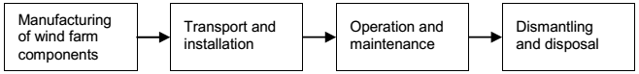

*Figure 5: Life Cycle of a Wind Farm [28].*

The most common method for estimating the impact of a wind farm on the environment is the Life Cycle Analysis/Assessment (LCA). The results from an LCA can vary according to the assumptions, for example, the recycling of the materials at the end of the lifespan. LCA is based on international standards (BSI, 2011; ISO, 2006a; ISO, 2006b; ISO, 2013) [32]. Despite the amount of uncertainty an LCA can have, it is the best tool to apply according to the data we have.

**Manufacturing of Wind Turbine Components:**

From the specifications of the WES100 the amount and type of materials is known (Appendix B). In the article [34] there is a summary of the carbon footprint from various materials. Using that data and specifications from WES100 fabricant we get the following table:

*Table 4: Emission of Wind Turbine Components*

|  |  |  |  |
| --- | --- | --- | --- |
| Parts | Weights (tonnes) | Material | Emission (tCO2) |
| Nacelle | 2.2 | Steel | 5.49 |
| Covers | 0.04 | Polyester | 0.16 |
| Tower | 5.213 | Steel | 12.98 |
| Bladesx2 | 0.2 | Fiber Glass/ Epoxy | 0.38 |
| Rotor | 0.9 | Steel | 2.24 |
| Control Cabinet | 0.4 | Steel | 1 |
| Gear Box | 0.820 | Steel/Oil | 2 |
| Generator | 0.4 | Iron/Steel/Copper | 0.54 |

**Transportation Emissions:**

For the transportation of the turbines and all other equipment to the site, it was assumed each heavy goods vehicles (HGVs) travel 200miles. The average consumption of this lorry can be found on [35]. In addition, the emissions due to transporting all components by sea to Great Cumbrae were considered.

**Installation Emissions:**

During the installation, more materials are added to reinforce the structures. The two main materials used in considerable amount is concrete and steel. It will depend on the foundation design, but for stiff soil, concrete foundation with steel anchors are typically used [36]. The amount of concrete and steel is estimated according to the height of the tower using previous studies on 100kW turbines [34] [37]. Other relevant carbon emissions during the construction are the cranes and excavations. Both are measured in tCO2 emitted per hour and are considered.

As result of the calculations above on production, transportation and installation emissions, production accounts for around 47%, transportation for 3% and installation for 50%. These values are typical for wind turbines rated up to 900kW [34].

The following calculations shows the payback amount of the wind farm.

Step 1, Output Power (O):

From section 3, the output of one turbine during the 20-year lifetime is O = (172MWh x 20years) 3440MWh.

Step 2, Carbon Intensity (*I*):

Carbon Intensity (*I*) allows for the comparison of performance between turbines. It is calculated using the life expectancy, the offset generated in the manufacturing, transportation and installation (Figure 5) divided by the total power generated for the turbine during the life time set by the manufacturer.

*E:* Total emissions previously calculated from the manufacturing stage until installation.

Step 3, Payback Time:

For the calculation of the payback time, it was required to assume the carbon intensity for conventional energy generation for the UK (569.9 kgCO2/MWh) [38]. With this value and the offset in kgCO2, *M* can be calculated.

*M:* value required for conventional energy generation to reach the offset of the present design.

0.258: the average load factor for onshore wind turbines for the UK [39].

Step 4, Payback Time per Day (*R*):

Step 5, Tones of Carbon Saved (*S*):

H: MWh produce by the turbine during the payback period.

For the present design for a wind farm in the island of Great Cumbrae, it is estimated to save 1854 tonnes of CO2. The payback period represents 5.4% of the life expectancy. The values explained above are subject to long terms changes that could modify this data. It was calculated with estimations from previous studies. For this case, the estimation selection was for the greatest one between the possible ranges to assume a worst-case scenario, for example, the amount of Carbon emissions during the installation.

The carbon savings can also vary depending on the decommissioning process. Decommissioning would also have carbon emissions included when choosing the higher estimated values. If the recycling of materials is performed, it would increase the carbon savings. If the foundations are left or reuse on the same site it would increase the carbon savings and reduce the carbon emissions when decommissioning. In conclusion, by only recycling steel (the material with the largest amount used) it would considerably increase the amount of carbon saved, usually 90% of the material can be recovered. But copper and iron can also be recycled. When decommissioning is performed as described, it usually represents 6% of the total carbon emissions of the lifetime of onshore wind farms, operation and maintenance cover another 6% [32].

All the data obtained from calculations is within the range expected for the turbines selected for this project. Thus, it can be compared with other conventional ways of producing electricity made in studies by ClimateXchange (Figure 6).

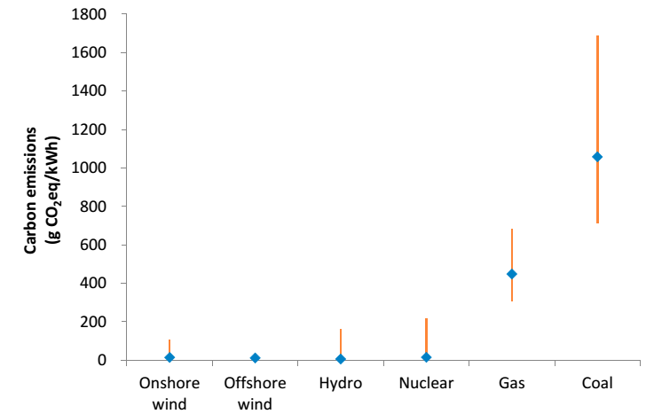

*Figure 6: Carbon Emission Comparison [28]*

6.2 Other Environmental Impacts

Reducing GHG is the aim of renewable energy. But there are other factors to consider including the changes brought to the environment and the public. The introduction of wind farms has created guidance by various organization to consider when designing a wind farm. These includes studies concerning noise, visual and shadow flicker of the wind turbines [40] [41].

In the case of noise, the studies recommend keeping the proximity to populated areas to below 2km. This distance applies to turbines with higher outputs. The present proposal of five WES100 turbines with an output of 100kW, produces a maximum of 45dB at 100m when working at 8m/s (Appendix B), this amount is much lower and should not be audible from the nearest households. Also, from the field trip conducted to Whitelee Windfarm (with turbines higher than 100m and rated to 2MW) it was concluded that it was not as noisy as expected.

Shadow effect and flicker relates to problems that can arise due to shadow flickering on people, houses or schools, for example. This effect could harm people psychologically in the long term. The location of the present project took this into account, it was chosen in a way that, for most of the day, the turbines is projecting the shadow to the shore, shown in Appendix A1. There are no houses between the towers and the sea. In the afternoon the shadow will start to project shadow to a section of the golf course. By the time the shadow could be long enough there will be no more residents or tourists in the surrounding fields due to the lack of artificial lighting.

Other reports state the possibility of interfering with TV signals or other similar signals. The blades of the WES are not made of metal, but with fibre glass and epoxy which does not reflect the signal wave passing through.

During the field trip, interviews were conducted to the public to find out their thoughts on the wind energy initiative by the government and how wind energy can be assimilated successfully. Most interviewees stated that they do not feel affected by the change in the landscape due to wind farms. They use the areas of the farms to do outdoors activities. Organizations like Scotland Power promote programs and invest in museums and other activities to raise awareness nationally and internationally on renewable energy.

By respecting the Ayrshire regulations for the island, the location selection does not affect or need to destroy any reservation areas. The planning safeguards the environmental integrity in terms of keeping the destruction of animal and plant population to a minimum.

The changes on the landscape are in line with the studies and guidance for small wind farms of lower height. This aspect in particular, has a subjective component to it but should not be unpleasant to view. As there are already other wind turbines that can be seen from the island, significantly higher than the WES100.

Last, but equally important, is to minimize the disturbance to residents for the duration of the wind farm. Together, with the construction manager, the planned route of equipment transportation to the site diminishes the possibility of destroying or modifying areas of M15 and M12, shown in Appendix A2, as these areas are protected by SNH. Leaving us with the use of the roads through Millport. Considerations will be taken in making as few trips as possible and to schedule trips to reduce disruptions (Figure 3).

1. Financial Analysis

7.1 Total Cost Calculation

7.1.1 Capital investment

The total estimated cost of the project can be divided into two parts: capital cost and annual cost. Additionally, these then can be split further into several components. The cost of the main components of the wind turbine are provided by WES. The details are shown in Table 5.

*Table 5: Capital Investment*

|  |  |
| --- | --- |
| **Capital Investment** | **Cost (£)** |
| Wind Turbines | 810,000 |
| Transformers | 4275 |
| Foundation Concrete | 25,000 |
| Foundation and Cable Excavation | 15,000 |
| Cables from Turbine to Connection Point | 25,000 |
| Access Roads | 4875 |
| Turbine Control Housing | 2000 |
| Grid Connection (DNO) | 10,000 |
| Permits | 60,000 |
| Delivery | 43,290 |
| Machinery Rental | 20,000 |
| Labour | 90,000 |
| **Total** | **1,109,440** |

Some of these costs can be further divided. The cost of access roads can be divided into improving roads that already exists as well as making the new stretch to the turbines. The permit cost includes all consultants’ expenses for acquiring the permits, it includes costs regarding building permits and costs for being certified for the required standards. Moreover, the foundation includes the material that goes into the foundation as well as the soil boring and preparations that need to be done on site before the construction starts. The cost of the machinery rental is the rental of all big machinery that is required to execute the construction of this project. The labour cost includes the salary which will be paid for all the managers and workers. The expected time for each manager and worker is 1408 hours. The transportation cost includes the cost associated with getting materials to the island. The control houses include the material for the other structures on the site.

7.1.2 Operational Cost

In the annual expenditure of this project, the land lease cost is the most substantial part. There are various health and safety features that need to be considered during the operation, therefore insurance is necessary which can protect workers' right, if working in a very dangerous situation, such as the top of the turbine, inside the gearbox or with electrical equipment. The proposed maintenance hours for the project is 40 hours yearly, on top of which is a cost to have to continuously monitor the turbines [42]. The corporation tax in the UK for profits above and below£300,000 is 20% and 21% respectively [43]. Details are shown in Table 6.

*Table 6: Operational Costs*

|  |  |
| --- | --- |
| **Operational Cost** | **Annual Cost (£)** |
| Maintenance | 559 |
| Tax | 22,394 |
| Insurance | 2000 |
| Land Lease | 862 |
| Monitoring | 392 |

It is worth noting that the loan is a useful way to avoid the possible disruption of the capital chain caused by the company's huge investment in the initial period. After calculation, if the bank loan occupies 30% of the initial cost of capital in this project, the net present value of the future cash flow is higher [44]. Therefore, 30 percent of the initial investment in this project will be a bank loan, which is equivalent to 113,832 pounds of prepaid expenses, but may be reduced by receiving government grants. A 5% interest rate is assumed. The loan is repaid over 20 years. The repayment will be represented by R, the first year's repayment will be R1, and so on. R20 will be the 20th year's repayment. The equation of annual repayment can be found as follow:

ː

7.2 Total Income Calculation

As mentioned earlier in Section 3, the total energy produced by the 5 wind turbines in 20 years is 17.2GWh.

*Table 7: Income from Selling Electricity*

|  |  |
| --- | --- |
| Income from Selling Electricity | Income per Unit [45] |
| Original Tariff | 8.19p/kWh |
| Feed in Tariff | 4.83p/kWh |

From the above data the annual income from selling electricity could be calculated as follows:

7.3 Cash Flow and Feasibility Analysis

The primary investment, annual investment, as well as the estimated annual income have been listed in the previous section. The following analysis determines the financial feasibility of this project. The cumulative profit and discount cash flow for each year are shown in Table 8*: Cumulative Profit and Discount Cash Flow* and Appendix H. The formula of discount cash flow (present value) is shown as follows:

In this formula, ct represents the annual profit, i represents the discount rate, and t represents the year [46].

*Table 8: Cumulative Profit and Discount Cash Flow*



Net present value is a method of evaluating investment. It is generally believed that the greater the net present value of the investment, the better the return on the investment [46]. The formula of NPV is as follow:

Internal Rate of Return (IRR) is a metric used in capital budgeting to estimate the profitability of potential investments. The internal rate of return is the discount rate when the net present value is zero (NPV=0), so we get the following formula:

Where i is the IRR [47].

ROI measures the amount of return on an investment, relative to the investment’s cost. To calculate ROI, the benefit (or return) of an investment is divided by the cost of the investment. The result is expressed as a percentage or a ratio [48]. The profitability index is an index that attempts to identify the relationship between the costs and benefits of a proposed project using a ratio calculated as:

.

The discount rate refers to the interest rate used in discounted cash flow analysis to determine the present value of future cash flows. Recently, the discount rate is generally between 7% and 10% [49]. The values of the above indicators are shown in Table 9. Details can be found in the financial Appendix H.

*Table 9: Summary of Financial Indicators*

|  |  |  |  |  |
| --- | --- | --- | --- | --- |
| **NPV** | **IRR** | **ROI** | **Profitability Index** | **Discount Rate** |
| -386,955 | 3.32% | 0.24 | 0.65 | 8.50% |

7.4 Financial Summary

Through the analysis, we can see that the entire project begins to profit from the 15-year mark. Under normal circumstances, the expected return on investment is between 5% and 20%. The ROI of this project is 0.24, which is higher than 0.2. Therefore, from the perspective of ROI analysis, it can be considered a violent industry. From the perspective of IRR analysis, when the loan interest rate is 3.32%, this item breaks even. Therefore, considering the actual situation analysis, the project can be profitable. As for the analysis from the perspective of NPV, although the NPV analysis method is widely used, it is only applicable to the project which contains cash flow stability, small uncertainty, short time, and mature valuation. Therefore, even if the NPV of this project is less than zero, this does not mean that this project is not suitable for investment. In general, if the profitability index of an investment project is greater than 1.0, the investment project is acceptable. The higher the profitability index of an investment project, the greater the profitability of the investment project and the greater the feasibility of its investment. The profitability index of this project is 0.65, which means that this project may have insufficient profitability. In summary, the project's profits may not be able to achieve the expected values, but as a new project to develop the market it is a suitable choice.

1. Project Development and Work Schedule

8.1 Windfarm Development

Future consideration will be given to the construction of substations at some connection points for long-term and regulated use of wind power systems. Due to factors such as load, internal stress, wear, and corrosion during the daily use and operation of electrical equipment, conditions such as changes in morphology, composition, and electrical properties may occur at individual sites or as a whole. Reducing the reliability of electrical equipment can cause serious accidents.

The power transmission and transformation monitoring equipment mainly monitor the operating status of the electrical and mechanical equipment at the transmission and transformation links, and obtains relevant information of its operating conditions and running quality through various sensors to dynamically track the development status of various degradation processes. In order to ensure the safety, stability and reliability of the power equipment operation, the power maintenance management department can repair and replace the power equipment in a timely manner before the power equipment may malfunction or the performance degrades to affect normal operation. The benefits of using transformers in the power system can improve equipment utilization by 2% to 10%, save maintenance costs by 25% to 30%, and extend equipment life by 10% to 15%. The power transmission system used in power plants has a life span of 60 years for main transmission and transformation structures, 40 years for major primary equipment, and up to 20 years for major secondary equipment. This substation equipment also has the conditions for sustainable use of the future grid companies.

8.3 Work Schedule

As a part of wind farm design, the choice of route is crucial to the overall design of the line. Correct choice of route will affect whether the circuit design is safe, economical and reasonable. The procurement should also avoid the situation that all construction materials are supplied by one supplier. Several different suppliers should be selected to avoid the interruption of the supply of construction materials caused by a supplier's suspension of production due to unexpected circumstances. During transportation, certain transportation protection measures should be applied to key construction materials. Prevent equipment from being damaged due to collisions or weather during transport, which will affect the construction results.

Afterwards, the storage of construction materials to be used shall be done at the site where the material is delivered to the construction site. The staff needs to arrange special material storage locations to avoid the chaotic situation where the construction materials are piled up everywhere.

For the wind power project, the earliest need for topographic measurements, takes about 45 days.

Road exploration takes about 3 months.

These two belong to the wind turbine foundation：These two are above the basis of wind turbines, geological surveying and other links to join a total of 5 months

Wind turbine booster station and the control building：7 months

Transport cables：4 months

Wind farm layout of the cable：3 months

The tower is transported to the construction site：2 months

Wind turbines are transported to the project site：2 months

Wind turbine installation：4 months

Wind turbine commissioning：1 month

Wind turbine test：2-3 days

Assuming January 1 project started：

geological surveying：2018.1.1~2018.5.1

Wind turbine booster station and the control building: 2018.1.1~2018.7.1

Transport cables: 2018.2.1~2018.6.1

Wind farm layout of the cable: 2018.1.1~2018.4.1

The tower is transported to the construction site: 2018.4.1~2018.6.1

Wind turbines are transported to the project site：2018.4.1~2018.6.1

Wind turbine installation：2018.4.1~2018.8.1

Wind turbine commissioning：2018.7.1~2018.8.1

Wind turbine test：2018.8.20~2018.8.22

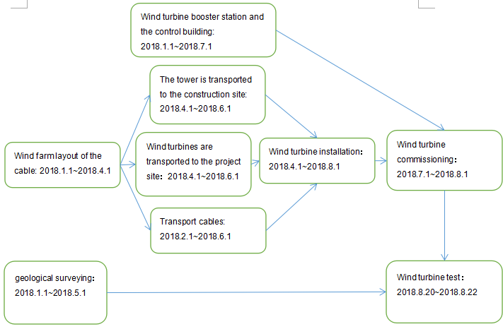

Figure : Critical Path Analysis of the project

The principle of path selection should follow the following points:

* The cable path should be short.
* Avoid cross-over with other pipelines.
* Avoid places to be constructed in the planning.
* Easy construction and maintenance.
* Do not subject cables to any kind of damage (mechanical, chemical, underground currents, water and soil corrosion, ants, etc.).
* Not close to flammable and other heat sources.

Finally, the amount of reinforced concrete in each fan base is approximately 150-500 cubic meters. Under the constraints of the total construction cycle, the continuous casting time for a single fan foundation will continue for a long period of time. It should up to 40 hours and not less than the minimum time of 10 hours. During continuous casting, attention should be paid to bleed air, micro expansion, water reduction and Retarded.

1. Conclusion

After researching Ayrshire Councils regulations, it was clear that there are a number of concerns relating to the implementation of wind turbines in Great Cumbrae. The region of Great Cumbrae has a very sensitive landscape, with many protected Scottish Wildlife Trust areas, radar sensitivity etc. Therefore, when the task of site selection arose it was vital to avoid issues that might threaten the validity of the project. Placing 5 turbines at Gowk Stone allows for the wind farm to stay within the council’s regulations. The only problems with this wind turbine site is that it is within the radar sensitivity region and it is only 0.7 miles away from the Millport. Although, those problems are offset by the use of such small turbines (26.95m to blade tip), due to their size, radar and visual impacts can be ignored, making the site feasible. Additionally, due to the size of the turbines the materials can be more easily transported round the island, with no alterations to existing infrastructure and only one major road requiring to be built directly to the site.

Great Cumbrae consumes approximately 6GWh of energy per year, while the 5 WES 100 turbines can only produce approximately 860MWh per year, which is approximately 14% of the islands energy consumption. Initially, the aim of this study was to power the entire island, although, this report suggests that a more diverse network of renewables is far more feasible and that 14% from wind is in fact very beneficial.

By implementing the wind farm, 1854 tonnes of CO2 can be saved, while it has a payback period of 5.4% of its expected turbine lifespan. Furthermore, as the windfarm is in line with the Ayrshire Councils regulations for the island, the site selection does not impact any reservation areas. The project planning has safeguarded the integrity of the environment and will cause minimum disturbance for residents. Therefore, environmentally the project is feasible.

Based on the economic analysis, we can see that the windfarm begins to make a profit after 15 years. With an expected return on investment between 5-20%. The ROI of this project is 0.24 and the project breaks even when the loan interest rate is 3.32%. Also, the profitability index of the project is 0.65, which means that this project may have insufficient profitability. Although as these types of projects are required to develop the market it may be possible to claim government funding. It is difficult to predict whether the project will become profitable, but it is feasible to suggest that it is possible.

Having conducted interviews with citizens of Great Cumbrae it was clear that most people believed that they would not be affected by the change in the landscape due to wind farms. They would use the areas of the wind farms to do outdoors activities, such as walking and mountain biking. Organizations like Scotland Power promote programs and invest in museums and other activities to raise awareness nationally and internationally on renewable energy. It is important to have the public on side and it is believed that they would not be opposed to the wind farm development.

Overall, this study recommends that the windfarm design project is technically and environmentally **feasible.** There are risks and may be some initial hesitance for planning approval, although it has been shown that the huge benefits can mitigate the minor concerns with this project. Our organisation would also advice performing feasibility studies with other renewable technologies to identify whether Great Cumbrae can become fully sustainable.

1. References

|  |  |
| --- | --- |
| [1] | Douglas Wheeler Associates Ltd, “MILLPORT & CUMBRAE ECONOMIC PLAN,” 30 September 2015. [Online]. Available: https://www.north-ayrshire.gov.uk/Documents/CorporateServices/ChiefExecutive/EconomicDevelopment/millport-cumbrae-economic-action-plan-draft.pdf. |
| [2] | C. Corral, “Cable inspections on the Clyde,” 2nd August 2017. [Online]. Available: http://www.largsandmillportnews.com/news/millport/15449160.Cable_inspections_on_the_Clyde/. |
| [3] | Carol Anderson Landscape Associates, “Ayrshire Planning Guidance on Wind Farm Development,” 2013. [Online]. Available: https://www.north-ayrshire.gov.uk/Documents/CorporateServices/LegalProtective/LocalDevelopmentPlan/wind-farm-development-guidance.pdf. |
| [4] | Carol Anderson Landscape Associates, “North Ayrshire Supplementary Landscape Wind Capacity Study,” 2013. [Online]. Available: https://www.nature.scot/sites/default/files/2017-06/A1064296%20-%20North%20Ayrshire%20Supplementary%20Landscape%20Wind%20Capacity%20Study%20-%20Main%20Study%20Report%20-%20June%2025%202013.pdf. |
| [5] | Carol Anderson Landscape Associates, “North Ayrshire Supplementary Landscape Wind Capacity Study,” 2013. |
| [6] | C. Anderson, “Landscape Capacity Study for Wind Farm Development in North Ayrshire,” Landscape Architects, October 2009. [Online]. Available: https://www.north-ayrshire.gov.uk/Documents/CorporateServices/LegalProtective/LocalDevelopmentPlan/WindFarmCapacityPhase2.pdf. |
| [7] | T. S. S. P. &. Infrastruce, “Supporting Information Paper 3 Nature Conservation Sites,” [Online]. Available: https://www.north-ayrshire.gov.uk/Documents/CorporateServices/LegalProtective/LocalDevelopmentPlan/nature-conservation-sites.pdf. |
| [8] | W. Carling, “SEA Screening Report,” December 2013. [Online]. Available: https://www.north-ayrshire.gov.uk/Documents/CorporateServices/ChiefExecutive/PolicyandPerformance/SEA-Screening-Ayrshire-Wind-V01.pdf. |
| [9] | North Ayrshire Council, “Local Development Plan,” [Online]. Available: https://www.north-ayrshire.gov.uk/Documents/CorporateServices/LegalProtective/LocalDevelopmentPlan/post-examination/supporting-information-papers-LDP.pdf. |
| [10] | C. Aldred, “Scottish Island Fedaration,” [Online]. Available: http://www.scottish-islands-federation.co.uk/wp-content/uploads/2016/01/Mull-Energy-Audit-Report.pdf. [Accessed 21 1 2018]. |
| [11] | WES, “WES,” [Online]. Available: https://windenergysolutions.nl/turbines/wes-100/. [Accessed 8 2 2018]. |
| [12] | Redcotec, “Network Assesment,” Redcotec, [Online]. Available: http://www.redcotec.co.uk/grid-connection/network-assessments.aspx. [Accessed 8 3 2018]. |
| [13] | Redcotec, “Wind Turbine Requirements,” Redcotec, [Online]. Available: www.redcotec.co.uk/grid-connection/wind-turbine-requirements.aspx. [Accessed 08 03 2018]. |
| [14] | DCODE, “Distribution Code of Licensed Distribution Network Operators of great Britain,” [Online]. Available: http://www.dcode.org.uk/assets/uploads/DCode_010318_v30.pdf. [Accessed 9 3 2018]. |
| [15] | National Grid Electricty Transmission, “Grid Code,” 21 21 2017. [Online]. Available: https://www.nationalgrid.com/sites/default/files/documents/8589935310-Complete%20Grid%20Code.pdf. [Accessed 09 03 2018]. |
| [16] | Energy Network Association, “DG Connection Guides,” 6 2017. [Online]. Available: http://www.energynetworks.org/assets/files/electricity/engineering/distributed%20generation/DG%20Connection%20Guides/June%202017/DGCG%20G59%20full%20June%202017.pdf. [Accessed 8 3 2018]. |
| [17] | IPU Group, “G59 Mains Protection Relays,” IPU Group, [Online]. Available: https://www.ipu.co.uk/products/comap-g59-mains-protection-relays/. [Accessed 12 3 2018]. |
| [18] | MeteoBlue, “Climate Great Cumbrae Island,” MeteoBlue, [Online]. Available: https://www.meteoblue.com/en/weather/forecast/modelclimate/great-cumbrae-island_united-kingdom_2648125. [Accessed 16 1 2018]. |
| [19] | C. Á. C. a. S. R.-M. Francisco Bañuelos-Ruedas, “intechwebs,” [Online]. Available: p100 http://cdn.intechweb.org/pdfs/17121.pdf. [Accessed 30 1 2018]. |
| [20] | Bright Hub, “Optimum WInd Turbine Spacing,” [Online]. Available: http://www.brighthub.com/environment/renewable-energy/articles/97151.aspx. [Accessed 21 2 2018]. |
| [21] | Energypedia, “Layout of Wind Projects,” Energypedia, [Online]. Available: https://energypedia.info/wiki/Layout_of_Wind_Projects. [Accessed 21 2 21]. |
| [22] | M. H. A. L.Fingersh, “Wind Turbine Design Cost and Scaling Model,” December 2006. |
| [23] | M. S. Cody McGregor, “Design for a wind farm in the Town of Auburn,MA,” April 29,2010. |
| [24] | “UK Contractor Services,” [Online]. Available: http://www.ukcontractors.net/builders-uk-is-there-a-set-time-builders-are-allowed-to-work-in-a-residential-area/. [Accessed 10 03 2018]. |
| [25] | “Renewable energy world,” [Online]. Available: http://www.renewableenergyworld.com/articles/print/volume-15/issue-1/wind-power/offshore-wind-turbines-transporters-rise-to-the-challenge.html. [Accessed 10 03 2018]. |
| [26] | Morrison Hershfield Limited, “HAF WIND ENERGY PROJECT,” April, 2012. |
| [27] | G. M. B.Maples, “Installation, Operation,and Maintenance Strategies to Reduce the Cost of Offshore Wind Energy,” July 2013. |
| [28] | Rodrigo, Risk Assessment of a Wind farm, the WritePass journal, November 24, 2012, p. 4.2 Risk Factors. |
| [29] | D. &. A. C. Anton, ISO 9001 Survival Guide. AEM Pub.., 2006. |
| [30] | L. F. &. P. M. Spira, “Risk management: The reinvention of internal control and the changing role of internal audit,” *Accounting, Auditing & Accountability Journal,* pp. 640-661, 2003. |
| [31] | F. G. E. S. A. S. C. A. &. W. D. A. Burton, “Corporate managers' reliance on internal auditor recommendations.,” *Auditing: A Journal of Practice & Theory,* pp. 151-166, 2006. |
| [32] | G. P. H. R Camilla Thomson, “Life cycle costs and carbon emissions of wind power,” University of Edinburgh, 2015. |
| [33] | RenewableUK. [Online]. Available: http://www.renewableuk.com/page/UKWEDExplained. |
| [34] | K. F. S. B. a. O. G. K. E. A. Smoucha, “Life Cycle Analysis of the Embodied Carbon Emissions from 14 Wind Turbines with Rated Powers between 50 Kw and 3.4 Mw,” *Journal of Fundamentals and Renewables Energy and Applications,* Abril 2016. |
| [35] | GOV.UK, 2016. [Online]. Available: https://www.gov.uk/government/statistical-data-sets/env01-fuel-consumption. |
| [36] | H. Svensson, “Design of Foundations for Wind Turbines,” Master Dissertation, University of Lund, 2010. |
| [37] | M. F. Tremeac B, “Life cycle analysis of 4.5 MW and 250 W wind turbines,” October 2009. [Online]. Available: https://www.sciencedirect.com/science/article/pii/S1364032109000045. |
| [38] | D. o. E. &. C. Change, “National Statics UK,” 27 March 2014. [Online]. Available: https://www.gov.uk/government/uploads/system/uploads/attachment_data/file/295968/20140327_2013_UK_Greenhouse_Gas_Emissions_Provisional_Figures.pdf. |
| [39] | Energy and Climate Change, “renewableUK,” May 2012. [Online]. Available: https://www.gov.uk/government/uploads/system/uploads/attachment_data/file/48359/5229-onshore-wind-direct--wider-economic-impacts.pdf. |
| [40] | ClimateXchange, “Wind Farm Impact Study, Review of the visual, shadow flicker and noise impacts of onshore wind farms,” July 2015. |
| [41] | ClimateXchange and LUC, “A Scoping Study on Assessment Practices for Noise Impacts from Renewable Technologies,” 2017. |
| [42] | Xn--drmstrre-64ad.dk., “Operation and Maintenance Costs for Wind Turbines. [online],” 2018. [Online]. Available: http://xn--drmstrre-64ad.dk/wp-content/wind/miller/windpower%20web/en/tour/econ/oandm.htm. [Accessed 17 March 2018]. |
| [43] | Gov.uk., “Environmental taxes, reliefs and schemes for businesses - GOV.UK.,” 2018. [Online]. Available: https://www.gov.uk/green-taxes-and-reliefs. [Accessed 17 March 2018]. |
| [44] | Renewables First - The Hydro and Wind Company., “Financing windpower projects - Renewables First.,” 2018. [Online]. Available: http://www.renewablesfirst.co.uk/windpower/investment-financing/financing-windpower-projects/. [Accessed 17 March 2018]. |
| [45] | Ofgem.gov.uk., “Feed-In Tariff (FIT) rates. [online],” 2018. [Online]. Available: https://www.ofgem.gov.uk/environmental-programmes/fit/fit-tariff-rates. [Accessed 17 March 2018]. |
| [46] | D. Kurt, “Net Present Value - NPV. [online] Investopedia.,” 2018. [Online]. Available: https://www.investopedia.com/terms/n/npv.asp. [Accessed 17 March 2018]. |
| [47] | I. Staff, “Internal Rate of Return - IRR. [online] Investopedia.,” 2018. [Online]. Available: https://www.investopedia.com/terms/i/irr.asp. [Accessed 17 March 2018]. |
| [48] | I. Staff, “Return On Investment - ROI. [online] Investopedia.,” 2018. [Online]. Available: https://www.investopedia.com/terms/r/returnoninvestment.asp. [Accessed 17 March 2018]. |
| [49] | C. Elvis Picardo, “Discount Rate.,” 2018. [Online]. Available: https://www.investopedia.com/terms/d/discountrate.asp. [Accessed 17 March 2018]. |
| [50] | Met Office, “Met Office,” [Online]. Available: https://www.metoffice.gov.uk/learning/wind/windiest-place-in-uk. [Accessed 23 2 2018]. |
| [51] | Renewable First, “What is the wind class of a wind turbine?,” [Online]. Available: http://www.renewablesfirst.co.uk/windpower/windpower-learning-centre/what-is-the-wind-class-of-a-wind-turbine/. [Accessed 24 1 2018]. |
| [52] | a. S. B. S. Adhikaria, “Dynamic analysis of wind turbine on flexible foundations,” pp. 37-56, 2009 8 2009. |
| [53] | S. T. Bungale, “Reinforced Concrete Design of Tall Buildings,” *CRC Press,* p. 263, 2009. |
| [54] | S. S. A. G. T. R. L. Boyun Guo, Offshores Pipelines: Design, Installation and Maintenance, 2004. |
| [55] | The National Academies of SCIENCES ENGINEERING MEDICINE, Worker Health and Safety on Offshore Wind, Washington, DC: 2018 National Academy of Sciences, 2013, pp. p38-p39. |
| [56] | Revolvy, “Great Cumbrae,” in *Marine environment and wildlife* . |
| [57] | "ntw_21-25c-27_construction_analysis," [Online]. Available: file:///C:/Users/Administrator/Desktop/%7BB4CCEEB4-3F84-4722-8655-C1DB61173CD9%7D.pdf. |
| [58] | *KEY FACTS: Wind turbine component deliveries to mid-Wales 2016,* 2016. |
| [59] | K. Smith, “WindPACT Turbine Design Scaling Studies,” Kirkland, Washington, March 27,2000 to December 31,2000. |
| [60] | “SUN&WIND ENERGY,” Offshore Wind Industry, [Online]. Available: http://www.sunwindenergy.com/news/longest-rotor-blade-world-travels-through-denmark. [Accessed 10 03 2018]. |
| [61] | “FINDING WIND ON THE NORTH ATLANTIC,” SEPTEMBER / OCTOBER 2016. [Online]. Available: http://www.windvinder.com/index.php?id=78. [Accessed 10 03 2018]. |
| [62] | I. Staff, “Discounted Cash Flow (DCF). [online] Investopedia.,” 2018. [Online]. Available: https://www.investopedia.com/terms/d/dcf.asp. [Accessed 17 March 2018]. |
| [63] | I. Staff, “Profitability Index. [online] Investopedia.,” 2018. [Online]. Available: https://www.investopedia.com/terms/p/profitability.asp. [Accessed 17 March 2018]. |

Appendix A: Site Diagrams

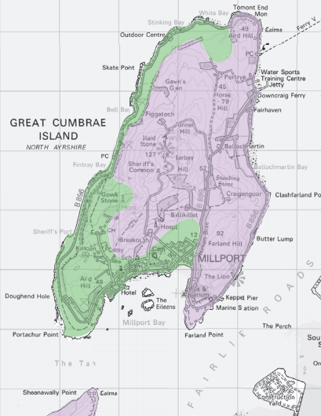

Figure A1: Detailed Landscape Character Areas

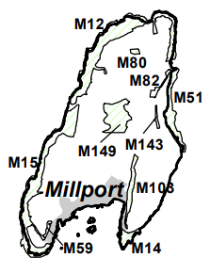

Figure A2: Great Cumbrae Local Nature Conservation Sites

Appendix B: WES100 Specification [11]

|  |  |
| --- | --- |
| WES100 General |  |
| Supplier/manufacturer | WES BV |
| Life expectancy | 20 years |
| Maintenance | Twice a year |
| Rated power | 100 kW |
| Cut in wind speed | <3 m/sec. (6.7mph) |
| Cut out/Recut in wind speed | 25 m/sec. (56mph) |
| Nominal wind speed | 13 m/sec. (28mph) |
| Survival wind speed | 60 m/sec. (134mph) |
| IEC Wind Class | IEC II |
| Passive power regulation | Pitching (blade-angle adjustment) |
| Active power regulation | Fully variable back-to-back IGBT system |
| Noise emission at 8 m/s | 45dB(a) at 100m |
| Operating temperatures | From -20°C up to +40°C |
|  |  |
| WES100 Applied standards |  |
| Degree of protection | IP55 |
| Standards | NEN1010 (electrical) EN50308 (safety) EN6096 (wind turbines) UL1741 (anti islanding) IIEC61346-2000 (cabinet) |
| CE-mark | Yes |
|  |  |
| WES100 Electrical |  |
| Grid voltage | 400V ±10% |
| Grid frequency | 50/60Hz ±3Hz |
| # Phases | 3 phase + neutral |
| Specific power | 393 W/m2 |
| Converter type | Back-to-back IGBT converter |
|  |  |
| WES100 Blades |  |
| Number of blades | 2 |
| Diameter | 17.9 m |
| Position | Upwind |
| Direction | Clockwise |
| Angle of the main shaft | 7° with horizontal |
| Swept area | 254 m2 |
| Speed | Variable 60 -120 rotations per minute |
| Power regulation | Passive pitching (blade-angle adjustment) |
| Min. blade-angle | 1 |
| Flapping angle | 180 -164° |
| Blade length | 7.8 m |
| Weight (1 blade) | 100kg |
| Chord | 500 – 625mm |
| Twist | 5° |
| Mounted | Flexible |
| WES100 Gearbox |  |
| Brand | Siemens (Flender) |
| Number of stages | 2 |
| Weight | 820kg (incl. oil) |
| Ratio | 0.055555556 |
|  |  |
| WES100 Generator |  |
| Brand | ABB |
| Type | A-synchronous |
| Nominal power | 100 kW |
| Number of poles | 4 |
| Nominal voltage | 230/400 volt |
| Frequency | Variable: 40 - 80 Hz. |
| Weight | 400kg |
| Protection | IP 55 |
|  |  |
| WES100 Tower |  |
| Type | Tubular |
| Number of sections | 2 or 3 |
| Tower height | 18, 24, 30 m |
| Material | Hot dip galvanised steel |
| Location ladder | External |
| Type | Lattice |
| Tower height | 31 m |
| Material | Hot dip galvanised steel |
| Location ladder | External |
|  |  |
| WES100 Controller |  |
| Control by | IPC (Beckhoff) |
| Remote monitoring | Yes |
| Data logging | Optional |
|  |  |
| WES100 Yaw-system |  |
| Yaw system | Active |
| Signal from | Wind vane |
| Driven by | Electro motor with worm-wheel reduction |
| Power yaw-motor | 0,55 kW |
| Yaw speed | 1,2°/sec. |
| Yaw bearing | Single ball bearing; externally geared (Rothe Erde) |
| Yaw-brakes | Constant friction-brakes; 4 pcs. |
|  |  |
| WES100 Safety |  |
| First safety system | Passive blade pitching |
| Activated by: | Rotor speed (110 rpm) |
| Second safety system | Yawing out of the wind |
| Activated by | Rotor speed (>120 rpm) |
|  | Excessive vibrations |
|  | Failure anemometer or wind vane |
|  | Grid failure |
|  | Fault in yawing system |
| Blocking system |  |
| Rotor blocking system | Pin in high speed shaft; for service purposes |
| Activation | Manual |
|  |  |
| WES100 Weights |  |
| Rotor incl. blades | 1.100 kg |
| Nacelle excluding rotor | 2.200 kg |
| Control cabinet | 400 kg |
| Tower | 7.820 kg (30 m. tower) |
|  |  |
| Material specifications |  |
| Blades | Carbon and fibre glass reinforced epoxy |
| Nacelle/rotor | Steel |
| Covers | Polyester |
| Tower | Steel (hot dip galvanised) |
| Foundation | Concrete Block with steel anchor |

The cut-in speed (wind speed at which the wind turbine starts turning and hence generating electricity) is a low 3m/s. A low cut in speed is preferred and a sizable portion of the wind in Cumbrae is of the less than 5m/s range (Appendix C [18]). The cut-out speed (speed at which the turbines stops rotating to avoid excessive loads on the turbine) and recut in speed (speed at which the turbine starts up again after a period of greater wind speed has been experienced) are both set to 25m/s. The wind turbine only restarts after a period of 10 minutes of wind speed less than the recut in speed is experienced. However, the turbine starts and stops the moment the cut-in and cut-out speeds are measured by the on-board anemometer. Moreover, the WES100 reduces damage caused by high speed by “feathering” the blades and then once even higher speeds are reached the turbine is yawed (nacelle is rotated) out of the direction of the prevailing wind.

The survival wind speed (speed at which the turbine can safely withstand) is rated at 134mph. The highest and 2nd highest recorded wind speed in Scotland in low elevation is 142 mph and 124mph respectively [50]. So, it is not expected that this will cause a problem to the WES 100. However, an add-on crane can be equipped to the turbine allowing the rotor to be removed when high winds are expected allowing the turbine to withstand extremely fierce winds. Regarding wind fatigue, the turbine is rated to a IEC wind class of II. Wind class II signifies the wind turbine has been designed to handle average winds of up to 8m/s [51], well within the calculated average wind speed of Cumbrae at 6.5m/s [18].

When the wind speed reaches 3m/s turbine will begin to spin, and the wind energy is transformed into electrical energy via a gearbox using an asynchronous generator. This is then send down the tower to the control unit at the ground. The control unit monitors the speed of the wind and controls the yawing, pitching of the turbine to direct the turbine into the wind or out of the wind when needed. The electrical energy is then passed through a transformer and send to the grid.

Appendix C: Wind Data Collected from Meteoblue [18]

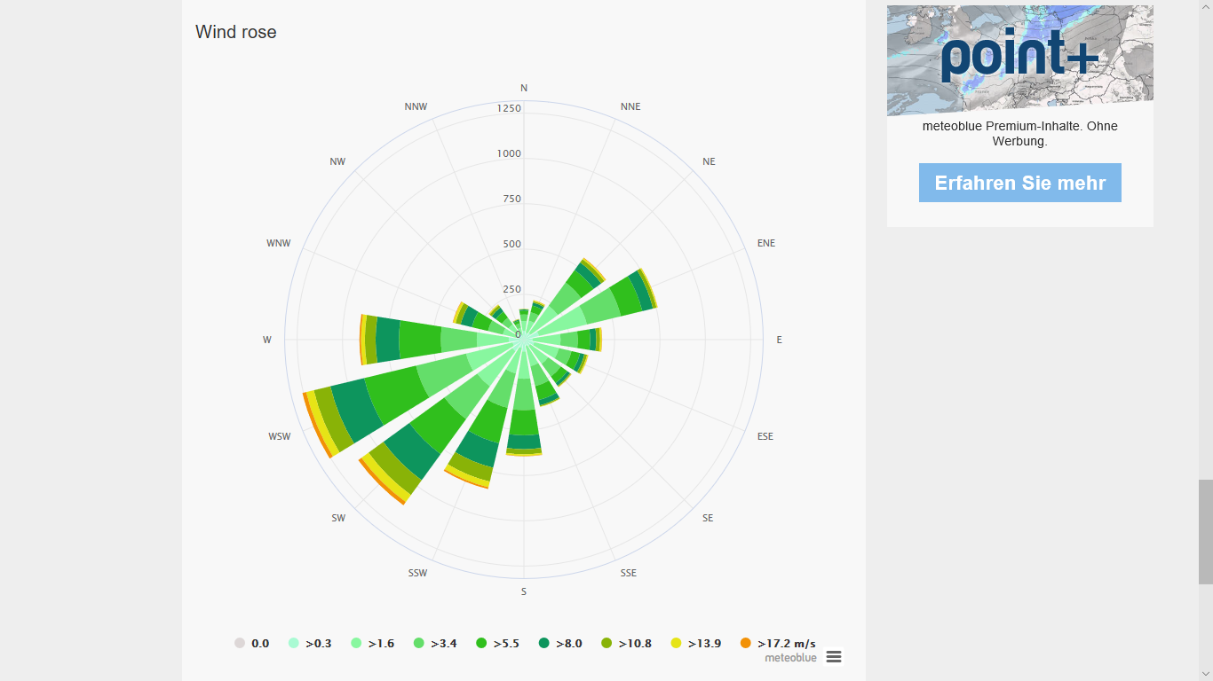

*Figure C1: Wind Rose of Great Cumbrae*

*Figure C2: Wind Speed Distribution of Great Cumbrae*



*Figure C3: Average Wind Speed of Great Cumbrae in 2017*

Using figure C3 the approximate average wind speed was calculated as 14.55mph = 6.5m/s.

Appendix D: Power Curve and Energy Production of the WES100 [11]

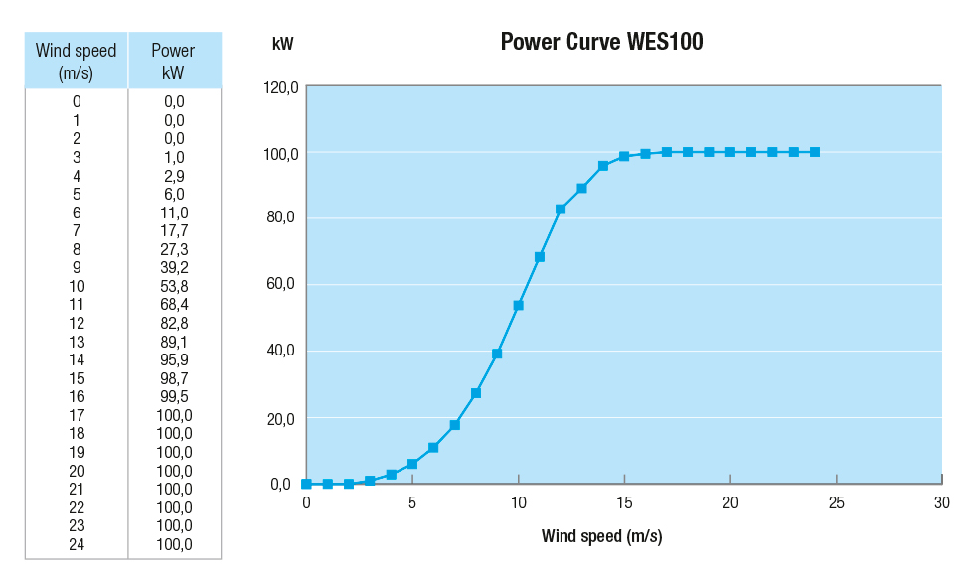

*Figure D1: Power Curve of the WES100*

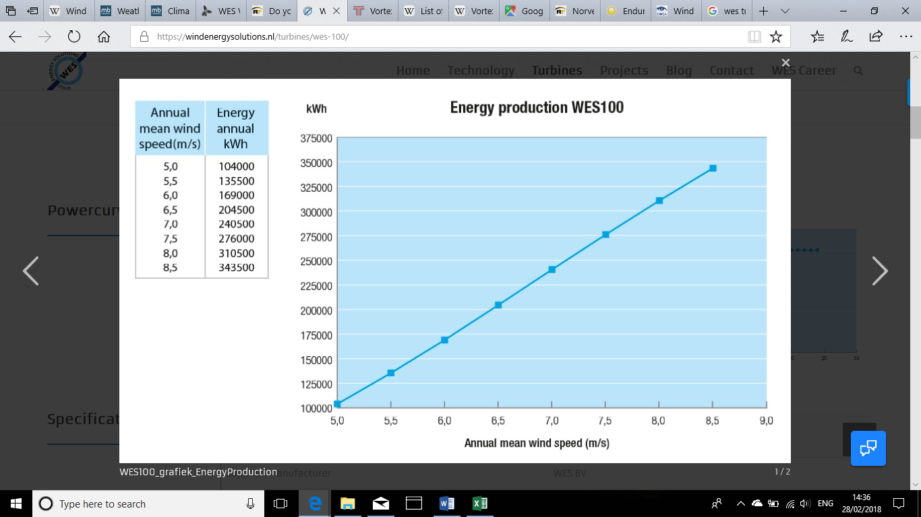

*Figure D2: Energy Production of the WES100*

Appendix E: WES100 Diagram

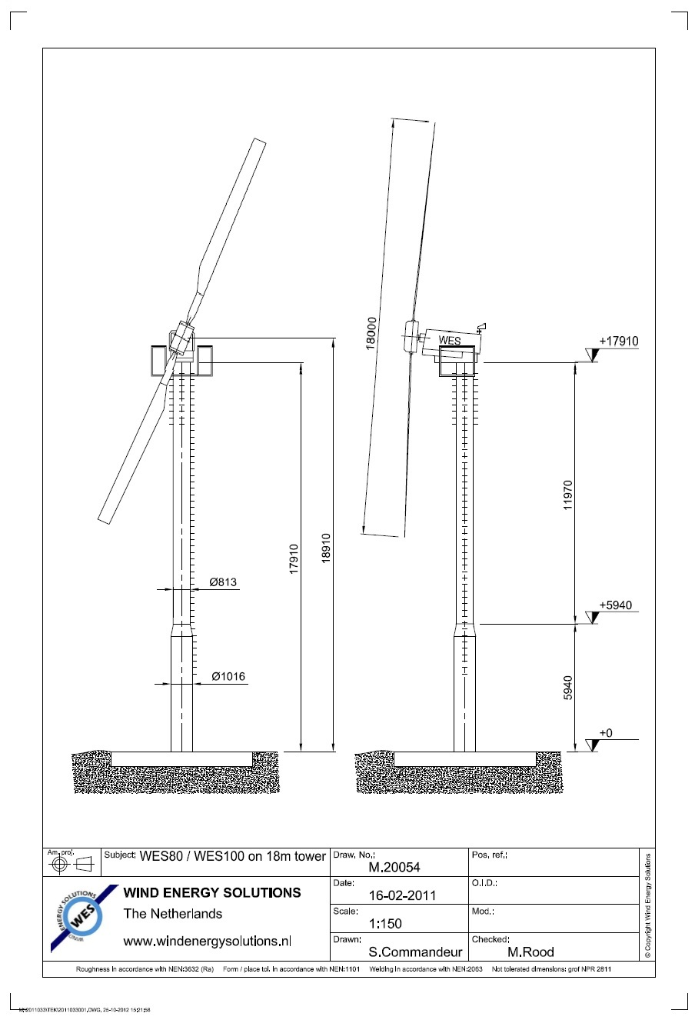

Appendix F: Natural Frequency and Vortex Shedding

Treating the wind turbine as a cantilever, the natural frequency can be calculated [52]

Where the wind turbine is modelled as a flag pole of length L, m is the mass per unit length, E is the young’s modulus, I is the area moment of inertia and M is the top mass.

From Appendix E, the upper part of tower is 11.97m, diameter is 0.813, and thickness .

The lower part of the tower is 5.94m, diameter is 1.016, and thickness .

for the whole tower, the moment of inertia could be expressed as

Using a Young’s Modulus for steel as The bending stiffness EI is:

The material of the tower is hot dip galvanized steel, the density of this material is:

7.87g/=7.87

Therefore, the mass per unit metre for the upper section of the tower is:

*/2*

And for the lower section:

*/2*

For the whole tower, the mass per unit could be expressed as:

The top mass of the wind turbine is (Appendix B: WES100 Specification [11]):

Therefore, the natural frequency is shown below:

**Vortex-Shedding Frequency**



*Figure F1: Vortex Shedding Behind A Circular Cylinder*

In fluid dynamics, vortex shedding is an oscillating flow that happens when a fluid like air or water flows pass a bluff body with a certain velocity. Vortex shedding frequency depends on the size and shape of the body. In this flow, vortices are created at the back of the body and detach periodically from either side of the body [53].

For the wind turbine, vortex-shedding frequency is the frequency at which pairs of vortices are shed from the tower and is calculated as [54]:

Where V is the wind velocity, D is the tower diameter. S is the Strouhal number which is a function of Reynolds Number, but a value of 0.22 is commonly used.

Comparing the natural frequency with the excitation frequencies from the vortex shedding from the tower, both frequencies are small and not the same and hence resonance can be avoided.

Appendix G: Risk Assessment [55] [28]

|  |  |  |  |
| --- | --- | --- | --- |
| **Hazard** | **Risk Factor** | **Action to control the hazard.** | **Risk Factor After Action** |
| Loading and unloading components for transportation may result in equipment being dropped from height. | 8 | All staff should wear personal protective equipment (PPE) (ie, safety helmet, steel toe cap boots, gloves). Safety consultant should arrange accident prevention. Machinery such as cranes and forklift should be used for large and/or heavy equipment | 3 |
| Roads around Cumbrae are small, tight and some unsuitable for big lorries. | 8 | The route to the construction site should be planned beforehand. Access road will have to build up to the site at Gowk Stone from the main road. Additional worker might have to be present to guide the lorry through any tight spots. | 4 |
| The usage of cranes to move large and heavy object can cause a crush hazards. | 8 | Firstly, all staff should wear protective equipment. Only one person (the banksman normally wearing the hi vis vest) will signal to the crane operator to avoid conflicting messages. The usage of hands free tool to push/pull equipment into place. And the usage of a tagline to stop the item from swaying out of control.  If higher winds are experienced crane work should be halted. | 4 |
| Workers often need to handle heavy equipment and act in awkward postures in cramped spaces, such as prolonged kneeling, repetitive body movements. This can cause fatigue, short and long-term sprains, muscle pains. | 16 | Firstly, workers should wear PPE.  The working time of each worker in awkward position should be limited. And proper manual handling technique should be used. | 8 |
| Slip and trip hazards. | 15 | Proper housekeeping should be done to keep the work area safe from any trip hazards. Any spills should be cleaned up or if it has been raining extra caution should be taken as to not slip from the rain or mud. | 8 |
| People who work at height (for example when connecting the nacelle to the tower) may need to climb the ladder several times per day, so they face fall hazards or exposure to the dropped objects. | 8 | Firstly, workers should wear a harness and fasten the work positioning belt when they need to work at heights.  Secondly, worker need to wear their PPE.  Thirdly, manager should arrange a plan when accident happens. | 3 |
| Workers might sometimes have to work in confined spaces where fumes, dust and toxic chemicals can be present. For example, when drilling has to be done. | 6 | As well as their normal PPE workers should wear sanitary mask if these types of work have to be carried out. | 2 |
| Wind turbine can also cause electrical hazards to workers, such as electrical burns and electrocution. | 10 | Firstly, workers should wear their PPE and protective rubber gloves before work.  Secondly, accident prevention is arranged completely e.g. emergency exit, fire alarm, fire extinguisher, fire hydrant. Extra care should be taken to isolate the electrical equipment. | 5 |
| Public areas are close by to the site. | 6 | Signs and barriers should warn and prevent to public from entering the construction. | 3 |
| Wind turbine can pose subtle health risks to nearby residents and workers. The sub-sonic noise generated by wind turbines is thought to cause headaches and sleeplessness, dizziness and even depression. | 4 | Firstly, the wind farm should be located far from residential areas. Secondly, isolation wall can be installed around the wind farm which can reduce the negative effects. Thirdly, workers should wear earplugs as well their regular PPE. | 1 |
| If a blade breaks free of the turbine, it becomes a very large and dangerous projectile. | 8 | Firstly, every worker need to wear their PPE. Regular maintenance to be adhered to (twice a year as recommended by WES) | 3 |

Appendix H: Financial Breakdown





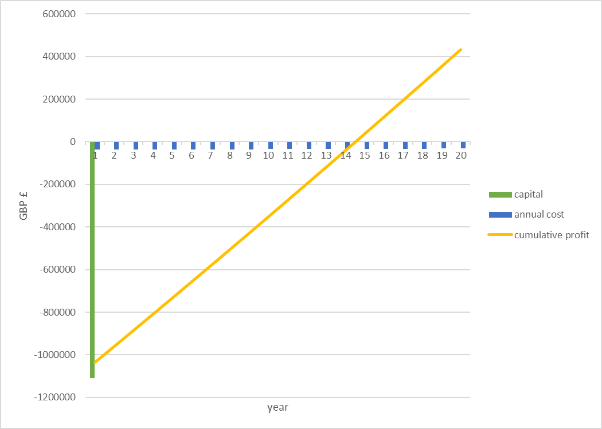

*Figure H1: Accumulated Profit*